**Results & Discussion**

Finite Element Analysis was carried out on six wheel configurations, combining three tread types (chevron, knobs, straight bars) with two support structures (honeycomb, spokes).

The material selected was Nylon 12 (3D printed wheels).

Each wheel was subjected to a static 30 N vertical load to represent the reaction force from the ground.

* Assuming a shoebox sized rover, the mass was estimated:
  + Frame (aluminium + printed bits): ~1 kg
  + 4 gearmotors (37–52 mm) + wheels: ~2 kg
  + Battery (80–120 Wh): ~0.8 kg
  + Suspension/rockers: ~1.0 kg
  + Electronics & sensors: ~0.5 kg
  + Misc.: ~0.7 kg  
    **Total:** ~6 kg
* N = mg
  + 6 * 10 = 60N
  + 60/4 = 15N per wheel
* Ndynamic = Nstatic * 2 (dynamic factor bumps)
* 15 * 2 = 30N per wheel

This load was applied across the bottom quarter or so of the wheel.

**The results are summarized below:**

|  |  |  |  |  |  |  |
| --- | --- | --- | --- | --- | --- | --- |
| Wheel Configuration | Material | Mass(g) | Load(N) | Max Von Mises Stress (MPa) | Max Displacement (mm) | Factor of Safety |
| Chevron + Honeycomb | nylon 12 | 15.969 | 30 | 3.093 | 0.024 | 14.872 |
| Chevron + Spokes | nylon12 | 15.862 | 30 | 7.885 | 0.062 | 5.834 |
| Knobs + Honeycomb | nylon12 | 16.741 | 30 | 2.893 | 0.02 | 15.902 |
| Knobs + Spokes | nylon 12 | 16.635 | 30 | 7.139 | 0.029 | 6.443 |
| Straight bar + Honeycomb | nylon12 | 16.806 | 30 | 2.792 | 0.018 | 16.475 |
| Straight bar + Spokes | nylon 12 | 16.7 | 30 | 6.617 | 0.018 | 6.951 |

**Observations**

* **Chevron + Honeycomb**
  + Stress hot spots were located at the internal crevasses of the inner most hexagons
  + Displacement hotspots were located on the outer tread on the bottom of the wheel slightly towards the rear. There were two distinct hot spots
  + 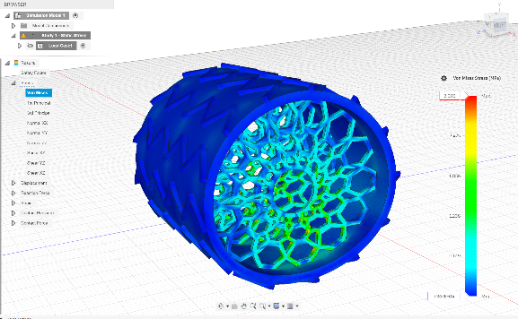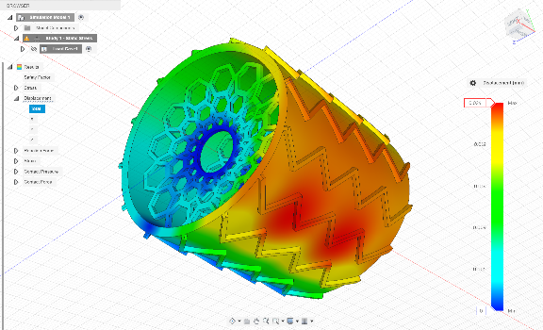

(Von mises stresses) (Displacement)

* **Chevron + Spokes**
  + Stress hot spots were located at the internal crevasses of the spokes all the way around the wheel
  + There was a uniform displacement hotspot rather than 2 distinct spots. The hotspot was more on the back face of the wheel, rather than the bottom.
  + 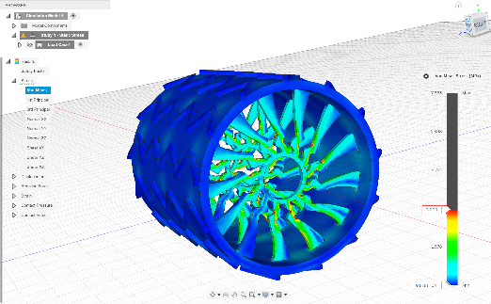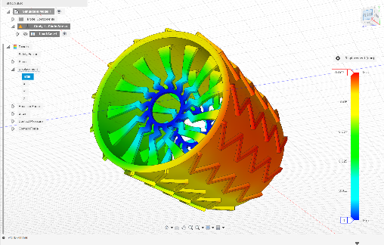

(Von Mises Stresses) (Displacement)

* **Knobs + Honeycomb**
  + Stress hotspots were located at the internal crevasses of the hexagons
  + Two distinct displacement hotspots were located on the bottom of the wheel, slightly towards the rear
  + 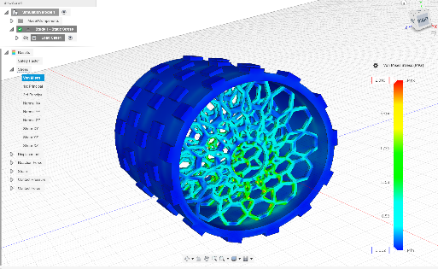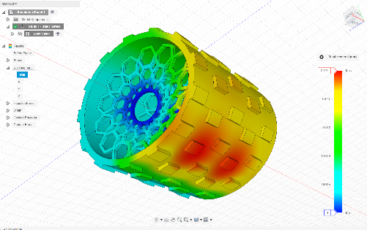

(Von Mises Stresses) (Displacement)

* **Knobs + Spokes**
  + Stress hotspots were located at the internal crevasses of the spokes closest to bottom of the wheel
  + A uniform hotspot of displacement was located on the back of the wheel, rather than the bottom.
  + 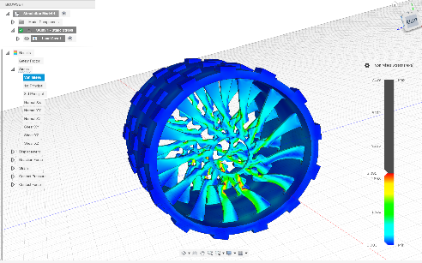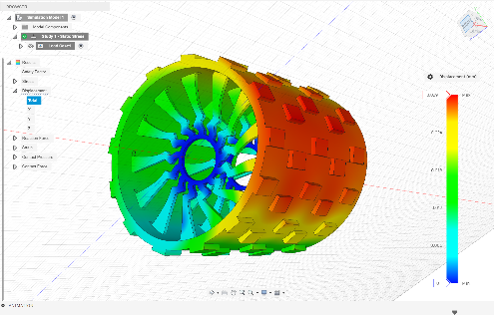

(Von Mises Stresses) (Displacement)

* **Straight Bar + Honeycomb**
  + Stress hotspots were located at the internal crevasses of honeycombs
  + Two distinct displacement hotspots were located on the bottom of wheel

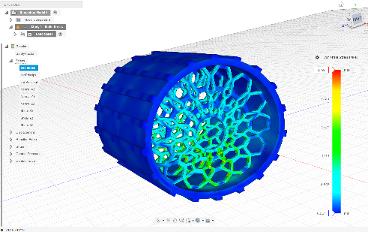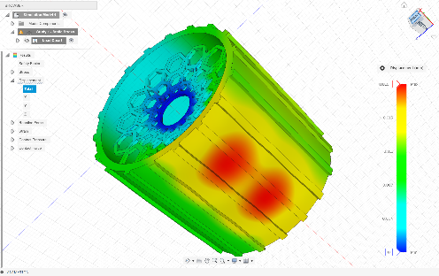

(Von Mises Stresses) (Displacement)

* **Straight Bar + Spokes**
  + Stress hotspots were located at the internal crevasses of the spokes closest to the ground
  + Two distinct displacement hotspots directly under the wheel

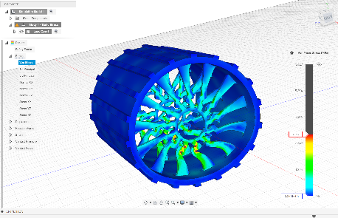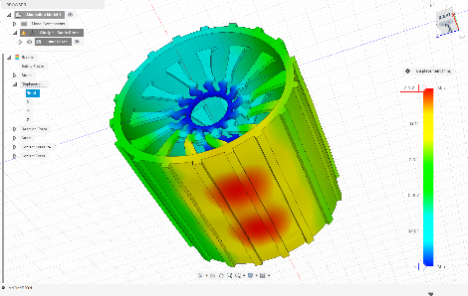

(Von Mises Stresses) (Displacement)

MATLAB was used to generate plots comparing the wheel designs:

Stress vs Displacement:

* A screenshot of a graph

  AI-generated content may be incorrect.

Factor of Safety

* A graph with blue rectangular bars

  AI-generated content may be incorrect.

Mass vs Factor of Safety

* A screenshot of a computer

  AI-generated content may be incorrect.

**Key Findings**

1. **Support Structure**:
   * Honeycomb consistently outperformed spokes in stress reduction, displacement control, and safety factor.
   * Spokes introduced concentrated stress at the root junctions, making them structurally weaker.
2. **Tread Design**:
   * Straight bars gave the lowest stresses and displacements, but at the cost of increased mass.
   * Knobs offer very good structural performance when combined with honeycomb but suffer from increased mass.
   * Chevrons were the best all-rounder, balancing low mass, low stress, and high safety.
3. **Best Overall Design**:
   * Chevron + Honeycomb emerged as the optimal design, with the lowest weight, strong structural performance, and hotspots in non-critical zones.
   * This mirrors real-world rover designs (e.g., NASA’s curiosity rover), where chevrons are used for traction.

(<https://www.planetary.org/space-images/diagram-of-a-curiosity-wheel#:~:text=There%20is%20a%20slight%20crown%20to%20the,which%20the%20wheel%20flexures%20(spokes)%20are%20attached>.)

This analysis shows that **support structure choice (honeycomb vs. spokes)** has a larger effect on structural integrity than tread type. Once the support structure is optimized, tread selection can be guided by terrain and traction requirements.